# Page Functionality Testing

Image Slider

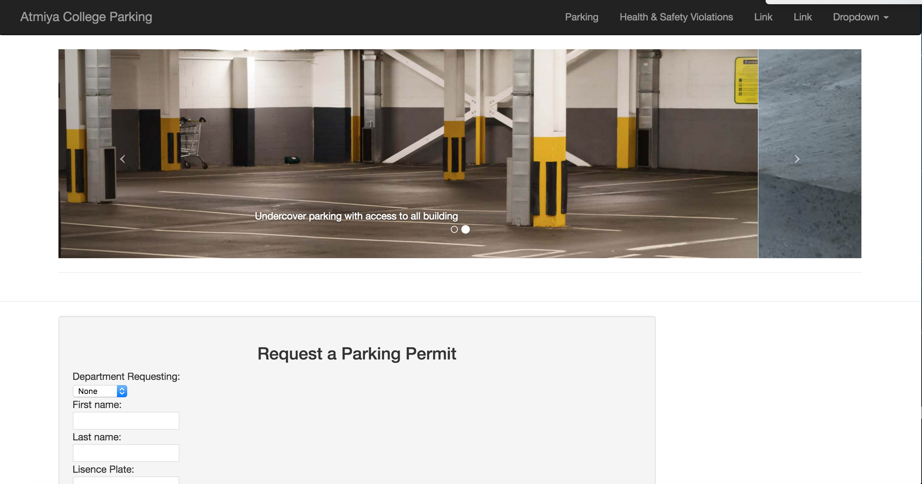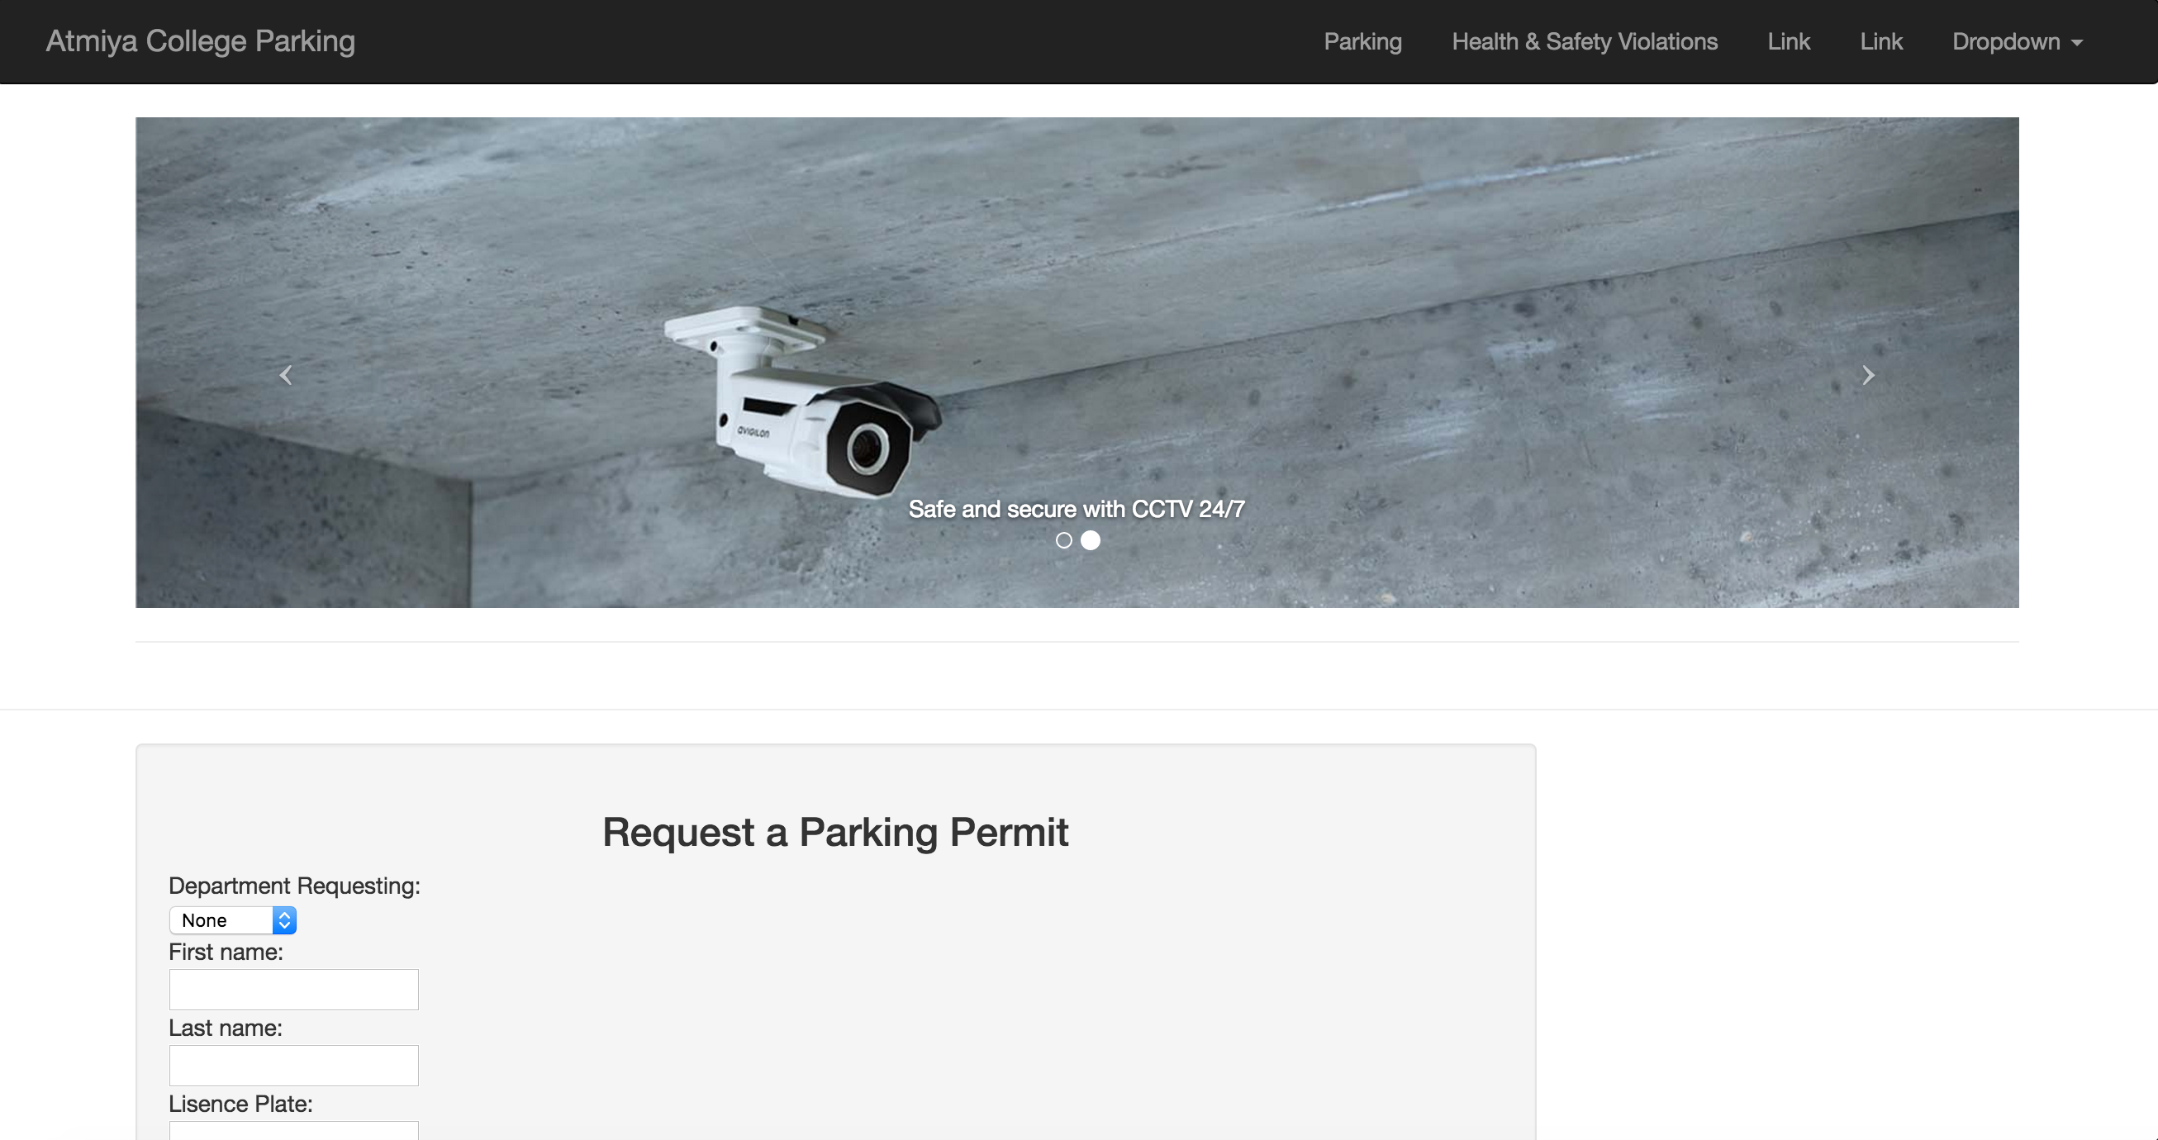

The image slider below the navigation bar can be changed both automatically or manually by clicking the arrows on each side of the image. These are done with javascript and work independently of the server backend.

Parking Permit Request Form

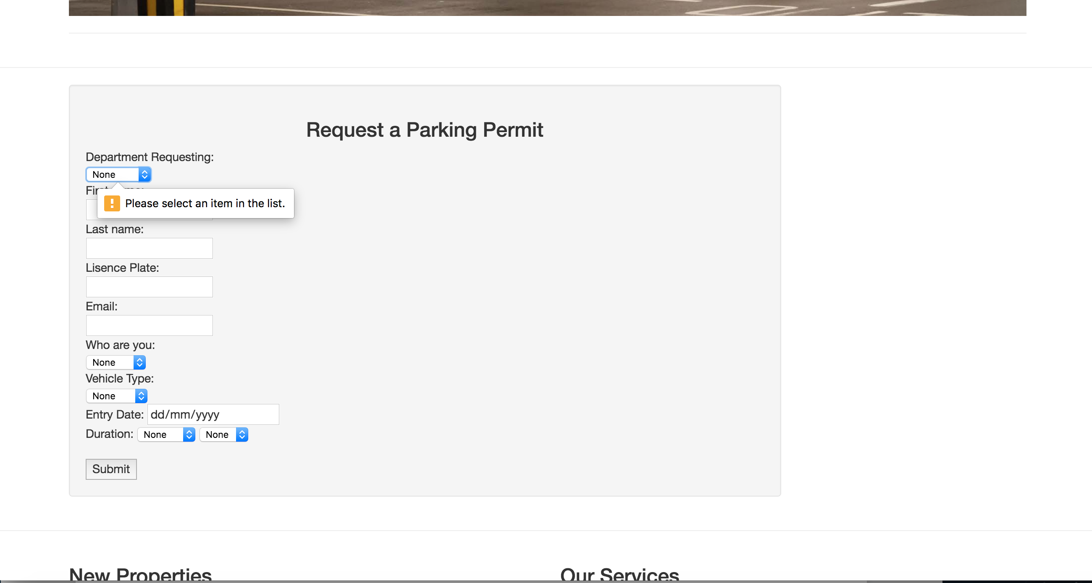

Every required textbox will need to be filled out, otherwise there will be a pop-up message to notify the user that the blank field needs to be filled out. We plan to add individual messages for each of the different types of fields in a later sprint.

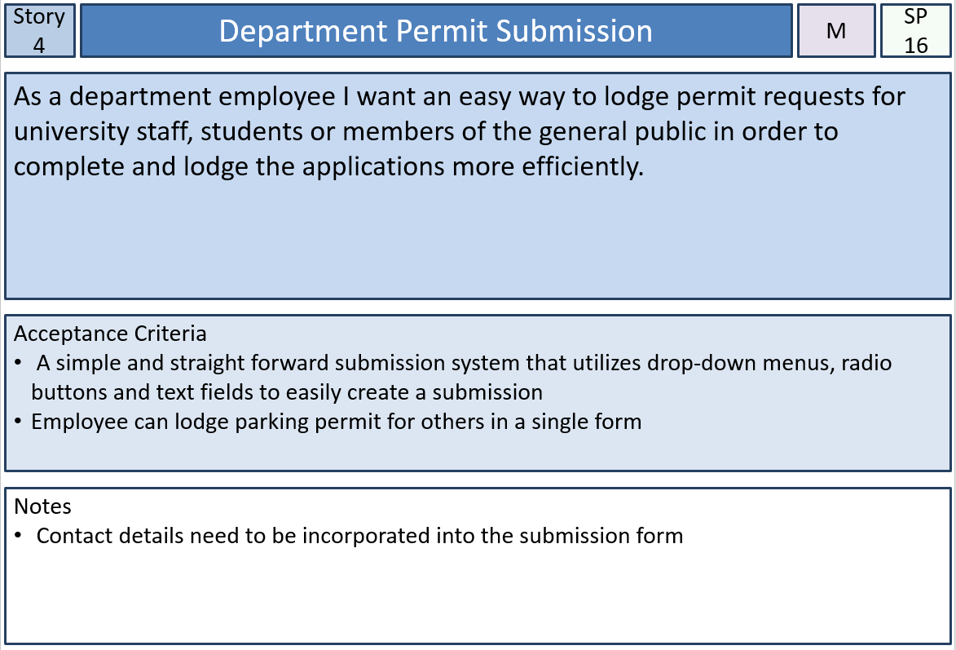

This functionality was implemented based on the acceptance criteria from user story 4 and makes sure that the parking permit submission form is simple and easy to use and is contained within a single form.

Registration Form

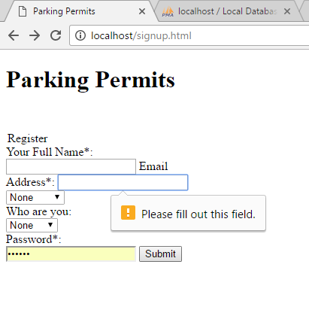

The register page has the same pop-up feature to notify users there are blanks in form as well. This will later have checks for valid names and passwords that will be added in a later sprint. This functionality didn’t have an associated user story and was included early on because most of the other pages in the website will require a login to get all of the functionality working properly.

Dropdown Menu and Navigation Buttons

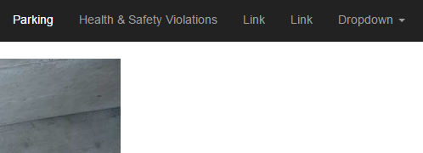

By clicking the buttons in the top navigation bar, users can be directed to the page they want and is currently working for the Parking page and Health & Safety page.

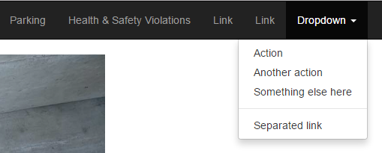

The dropdown box will hold the login and register links that will be added in a later sprint.

Database

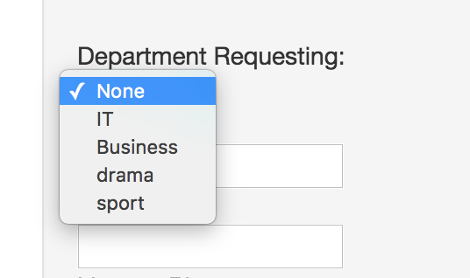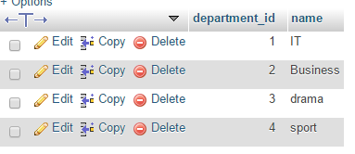

The department_id is saved upon registering an account, so that the webpages can be adjusted based on the department and level of privilege on the website. This can also be used for the search feature that is planned to be added in the next release.

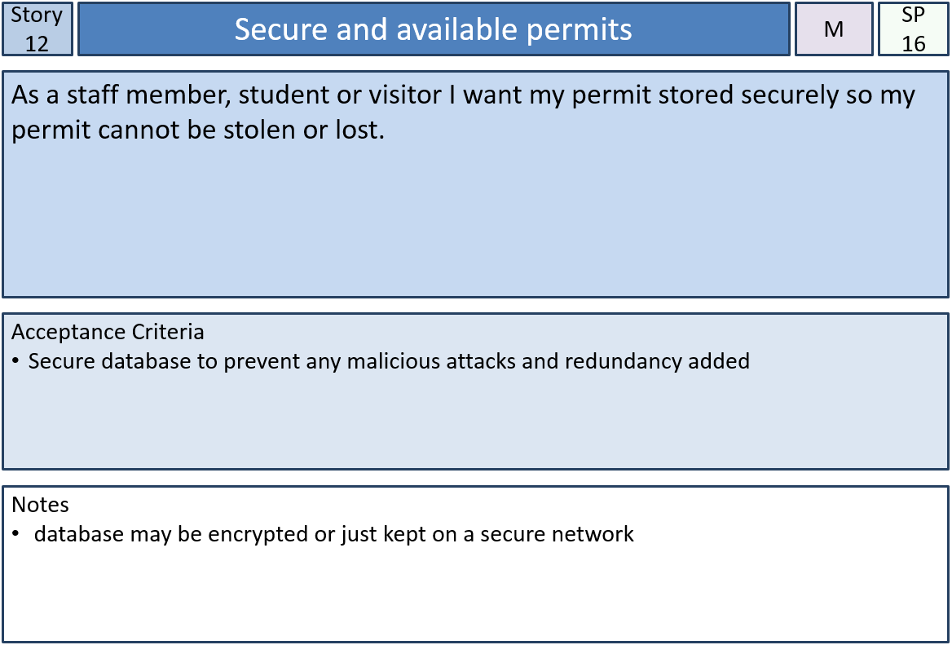The database was implemented to meet the acceptance criteria of story 12 that was implemented in sprint 1. The database is securely hosted on localhost for now and any passwords used during registration and login are hashed for added security.

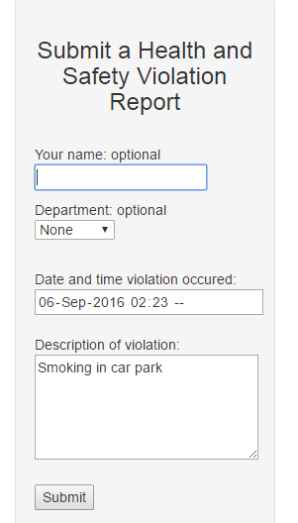Health and Safety Violation Form

The Health and Safety Violation form test, leave the optional part as blank and fill everything else in, and the report shows in the database, the optional part is null and things filled in are recorded correctly as seen in the two images below. The form bunches up on certain screen resolutions which the team is working to fix.

/Users/Sam/Downloads/screen captures/health violation database.PNG

Parking Permit Database Entries

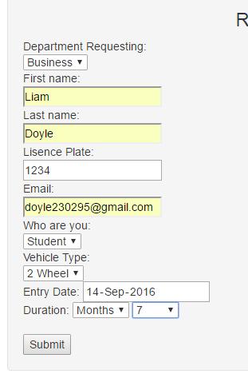

Parking Permit form test, after filling in all of the fields and submitting. The information successfully writes into database, and stores the data appropriately so that is can be used in the login page and as verification for modifying webpages based on who is accessing them. (This is from an old version before we made some updates to the database to the form currently does not submit to the database). This implementation is also a part of user story 12



Registration Database Entries

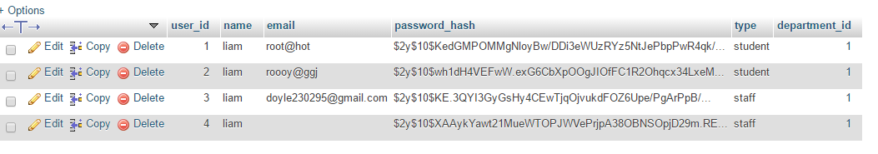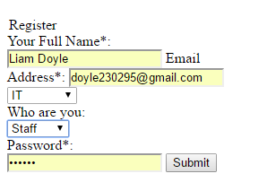After correctly filling in the registration form, the detailed information can be input into the database. The password for users will be hashed for the better security. Required fields are yet to be implemented and will be a part of the next sprint since the focus was on getting the database working with the registration information. This implementation was also a part of user story 12.